# Variables

console.log("test ")

const accountId = 23355;

let accountEmail = "siddharthnaudiyal@gmail.com";

var accountPassword = "Sidhu#daf";

accountCity = "Jaipur";

console.table([accountEmail,accountId,accountPassword,accountCity])

**const** means it cant be changed

**let** and **var difference =** we use let instead of var because in modern day javascript it solves a problem of scope (“{ }”) var was like if u change var it also changes var in whole code irrespective of scope but let only assign value at that scope.

**Don’t use var because of issue in block scope and functional scope.**

* You can assign value in variable without let var const too. It is possible in javascript
* And if you **let**  a variable without any value inside it. Node js would show undefined value

# Datatypes

**Number** 2 to power 53

**Bigint**

**String**

**Boolean** true false

**Null** stand alone value like you wont return zero if you temperature app aint working youll use null cuz zero is value

**Undefined**

**Symbol** unique

**Object**

**Typeof**  it tells you type of data types but type of null is **object**

# Data Conversion

let score = 33

let score2 = "45"

console.log(typeof(score))

let valueInNumber = Number(score2)

console.log(valueInNumber)

console.log(typeof valueInNumber)

**Typeof()** to know the type and **Number()** to convert it into number

* Syntax would be N capital or starts with capital
* When changing number if its not a number in string it will return **NaN**(not a number)
* **Null**  would be converted to **0**
* **Undefined** would be converted to **NaN**
* But they all would be typeof **number**

let isLoggedIn = 1

let isBoolean = Boolean(isLoggedIn)

console.log(isBoolean)

* 1 in Boolean is **true**
* **0** in Boolean is **false**
* **“ “**  is **false**
* **“Siddharth”** is **true**

# Conversion

console.log(null > 0)*//false*

console.log(null == 0)*//false*

console.log(null>=0) *//it converts null to zero (true)*

console.log("2"==2) *//true because it converts string to number auto*

console.log("2"===2)*// falase as it checks its data type too*

# Data types Summary

**Primitive Data types –** strings, number, bigInt, Boolean, null, undefined ,symbol.

They all call by value – that means when make changes they are copy not the actual thing in memory

**Non Primitive (Refrence) -**  Array, Object and Functions

JavaScript is a **dynamically typed language** ✅

That means:

* You **don’t need to declare the type** of a variable when you create it.
* The **type is determined at runtime** (when the code runs), not at compile time.
* A variable can hold different types of values at different times.

const score = 100               *// Number datatype*

const scoreValue = 100.3        *// num*

const isLoggedIn = false        *// boolean*

const outsideTemparture = null  *// null*

let userEmail;                  *// undefined*

const value = Symbol('124')

const value2 = Symbol('124')

console.log(value2===value)  *// false they are unique*

**Datatype of null is Object**

# Stack and heap memory

**Stack(**primitive) as a copy data

let myname = "siddharth"

let anotherName = myname

anotherName = "sid"

console.log(myname)

console.log(anotherName)

it doesn’t change the name of my name

and **Heap (** non primitive) original data

let UserOne = {

    email: "siddharth@gmail.com",

    pass: "whatver"

}

let UserTwo = UserOne;

UserTwo.email = "hellw@gmail.com"

console.log(UserOne.email)  *//hellw@gmail*

console.log(UserTwo.email)  *//hellw#gmail*

it has changed cuz its pointing towards that memory not creating a copy

# Strings

Concatination of strings should be done by backstrick ` ` and ${ } to add and conctatinate string

const name = "SId"

const height = 44;

*// let nameHeight = name + height;*

*// console.log(nameHeighta)*

let nameHeight2 = `my name is ${name} and my height is ${height}`

console.log(nameHeight2)

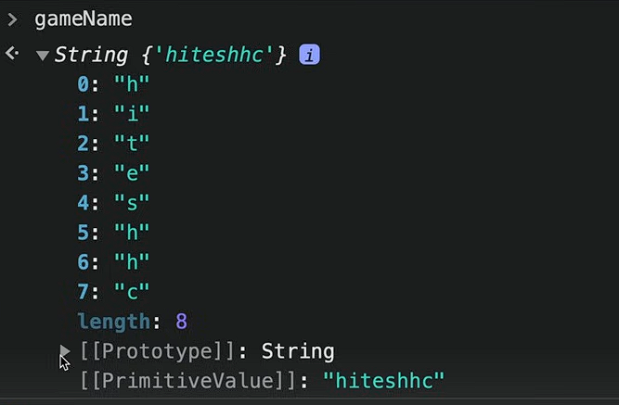strings is also an object collection of key value pair

let gameScore = new String ("hello")

console.log(gameScore)

defining a string. Normal string also look like this in background

let gameScore = new String ("hello")

console.log(gameScore)

console.log(gameScore[0])

console.log(gameScore.__proto__) *// this is not empty it will show alot of property if  you see this in broweser*

**Strings Methodology**

console.log(a.charAt(2));       *// telss the location of string at index 2*

console.log(a.toUpperCase());   *// converts to uppercase*

console.log(a.indexOf("i"));    *// returns the index of i in a*

**Slicing of Strings**

let newString = a.substring(0,3) *// doesnt obey negative value it will start from start*

console.log(newString)

const anotherString = a.slice(-8,4) *// it will obey negative value as well it will start from the end too*

console.log(anotherString)

**.trim() –** used usually when you are taking a form from user and he fills spaces in front or back unknowingly or knowingly

b = "      hello kutta        "

console.log(b)                  *// output :          hello kuttaa*

console.log(b.trim())           *// output : hello kutta (this removes the spaces from front and back)*

**.replace() –** to replace something in url or something

const url = "https://www.google.com/siddharth%20naudiyal"

console.log(url.replace("%20","-"))

**.include**

console.log(url.includes("sid"))

# Numbers and Maths

let score = 30

console.log(score)

let gameScore = new Number(882) *// this will set this as number and will give prototype in console of browser*

console.log(gameScore)

**Functions for number**

**.tostring ()**

console.log(gameScore.toString())  *// this will help to get all the strings function in number by converting*

**.tofixed()**

console.log(gameScore.toFixed(2)) *// this will show 882.00 means till two decimal places*

usually used in ecommerce websites

**.toprecision()**

let nameScore = 898.93

console.log(nameScore.toPrecision(3))

it will round off till the number you have given.

**.toLocaleString()**

const hundreds = 1000000000

console.log(hundreds.toLocaleString("en-In"))*// for indian decimals en-In is used*

this will put decimals according to digits leaving localestring as it is will give you American decimal system.

# Maths

**Maths** library comes inbuilt in javascript

console.log(Math);

Object [Math] {}

It is object

Go to browser and see more property of maths

**Functions of maths**

**Math.abs()-** absolute value

console.log(Math.abs(-4));*// will turn -4 into 4 but not 4 into -4 it gives the absolute value*

**Math.round() –** math.round off

console.log(Math.round(4.343)); *// output will be 4*

**Math.ceil and Math.floor –** as name suggests ceil means ceiling and floor means ground it will round off number if ceil it will give bigger number and floor will give nearest smaller number

console.log(Math.floor(4.343)); *// output 4*

console.log(Math.ceil(4.343)); *// output 5*

**Most importantly we have :**

**Math.random() –** it will give us a random number between 0 to 1

console.log(Math.random())                      *// this will give random no between 0 to 1*

console.log((Math.random()*10) + 1)             *// multipy by 10 gives 0 to 10 but we dont need zero as value so +1*

console.log(Math.floor((Math.random()*10) + 1))*// floor will remove all the decimal value*

to get range we have

const max = 20;

const min = 10;

console.log(Math.floor(Math.random() * (max - min + 1)+ min))

remember this formula

# Dates

It is object in javascript

const myCreatedDate = new Date(2023, 0 ,11)  *// Wed Jan 11 2023*

console.log(myCreatedDate.toDateString())

in js month starts from **0.**

const myCreatedDate = new Date("2004-11-23")  *// Tue Nov 23 2004,*

console.log(myCreatedDate.toDateString())

months will not start from zero if you put it inside string **yyyy-mm-dd**

let myTimeStamp = Date.now()

console.log(myTimeStamp)*//             this will return time in miliseconds 143554353426556*

console.log(myCreatedDate.getTime())    *//this will convert date in miliseconds 343215145*

**used in time buzzer** to get milliseconds who won or in booking apps you have to compare time in milliseconds.

myCreatedDate.toLocaleString("defualt",{

    weekday:"long";

})

We can customize.toLocaleString with many features.

# Array

Array is collection of multiple data stored in a single variable.

* Array in javascript is resizeable (you can add more items afterwards)
* Can contain different types of data
* 0 based indexing
* It creates shallow copy (heap memory) / same reference point
* Means if you change array you are changing the original.

let myarr = [0,2,3,4,5]

let myarr2 = new Array(1,3,"sid")

console.log(myarr)

console.log(myarr2)

creating array [ ] or new Array( )

when you see it on console you get prototype and inside prototype you get another prototype **object** one.

**Methods in array**

**Arr.push () -**  insert item at last

myarr.push(8)

console.log(myarr)

**arr.pop( ) =** removes the last element in array

**arr.unshift =** adds element to the start of the array we are adivised not to use this because shifting array could be time consuming process consuming and get a load on the memory if we have a big array.

**Arr.shift( )** = it is pop but removes element from the start of the array

**Some checking functions**

**Arr.includes( ) =** tells you that it exist in the array or not. Returns value in Boolean

let array = [1,2,3,5,5,6,"sid", "kutta"]

console.log(array.includes(1)) *// boolean true*

**arr.indexOf() =** tells you the index of the something you put inside the function

console.log(array.indexOf("sid"))

**for conversion**

**arr.join( ) =** it joins converts the array into string and return with comma separated values.

const newArr = array.join()

console.log(newArr)

**Splice and Slice**

console.log("A ",array) *//A  [ 1, 2, 3, 5, 5, 6, 'sid', 'kutta' ]*

console.log("b ",array.slice(0,7)) *//b  [ 1, 2, 3, 5, 5, 6 ]*

console.log(array)*//                [ 1, 2, 3, 5, 5, 6, 'sid', 'kutta' ]*

console.log("c ",array.splice(0,7))*//c  [1 2, 3,5, 5, 6,'sid']*

console.log(array) *//[ 'kutta' ]*

**slice(0,6) –** 0 is the start index and 6 is the 6 places it slices and into the part but doesn’t change the original array

**splice()-** does the same thing but changes the original array.

**Diffrence between push and concat and spread**

**Push =**

let marvelHeros = ["IronMan","Spiderman","Captain"]

let dcHeros = ["batman","superman","flash"]

marvelHeros.push(dcHeros)

console.log(marvelHeros)

[

'IronMan',

'Spiderman',

'Captain',

[ 'batman', 'superman', 'flash' ] **this puts array inside the array.**

]

**Concat**

let marvelHeros = ["IronMan","Spiderman","Captain"]

let dcHeros = ["batman","superman","flash"]

allHeros = marvelHeros.concat(dcHeros)

console.log(allHeros)

**Spread**

Spread means spread example glass being broken into pieces all the water get in same thing

allHeros = [...dcHeros,...marvelHeros]

console.log(allHeros)

syntax [] imagne it like we burst water bubble inside a container array all their elements get collected there **mostly used in.**

**Flat()**

let anotherArray = [1,2,3,4,[5,6,7],[2,3,44,[23434,33]]]

let realArray = anotherArray.flat(Infinity)

console.log(realArray)

this is used when you have array inside array inside array or like a lot of ghichpich

.flat(number of depth) who much you want to flat.

Use.**flat(infinity)** tips and tricks

## Is of from in array

Used in data scraping

console.log(Array.isArray("siddharth")) *// false*

console.log(Array.from("siddharth")) *// ['s', 'i', 'd','d', 'h', 'a','r', 't', 'h']*

Array.isArray() tells you that is it a a**rray or not**

And array.from **coverts** into the array

Gives empty array if it cant covert it to array []

**Of**

let score1 = 100

let score2 = 200

let score3 = 300

let total_score = Array.of(score1,score2,score3)

console.log("Array of scores are ",total_score)

# Objects

We can declare objects in two ways litreals and Constructors

When we make object using Constructors it makes a **singleton** ( singleton means this object is unique it is one of its kind)

Litreals don’t create objects as a singleton

const names = {

    name1: "sid",

    name2: "tannu",

    name3: "saksham",

    name4: "sejal"

}

Object

**Accessing**

We got two ways dot method . and [] method

**dot method**

console.log(names.name1)

**bracket method (prefferd)**

console.log(names["name1"])

remember that it should be on strings when you put key there

**putting symbol data type in the object**

*// objects litreals*

const mysym = Symbol("key1");

const names = {

    name1: "sid",

    [mysym]:"this is key1",

    name2: "tannu",

    name3: "saksham",

    name4: "sejal"

}

console.log(names[mysym])

this will return value as a symbol not as a string this is the only way to get it like that.

**To override current value**

names.name1 = "the_sid_supreme"

**object.freeze()**

names.name1 = "the_sid_supreme"

console.log(names.name1);

Object.freeze(names)

This will make the object freeze meaning no more changes ahead.

**Adding greetings from object**

names.greeting = function () {

    console.log(`hello ${this.name1}`)

}

console.log(names.greeting())

**so** with already existing object we added greeting

with **this.name** and you should write **greeting()** not **greeting** because it will return annonymus function as output.

# Object through constructor

Declaring object through constructor creates a singleton.

**Declaration in constructor**

1. **Singleton**

const TinderApp = new Object(); *// this creates a singleton means its unique object*

1. **Literal**

const tinder = {}

**Object inside a object**

const RaindropPlayer = {

    fullName:{

        first:"siddharth",

        last:"Naudiyal"

    },

    id:{

        user:"1",

        user2:"2"

    }

}

**To access use dot operator**

**Console.log(RaindropPlayer.fullname)**

**Combining the object**

**Method 1 – { }**

const obj1 = {

    1:"a",

    2:"b"

}

const obj2 = {

    3:"a",

    4:"b"

}

let obj3 = {obj1,obj2}

console.log(obj3);

let obj3 = { }

**Method 2 = assign()**

const obj1 = {

    1:"a",

    2:"b"

}

const obj2 = {

    3:"a",

    4:"b"

}

*// let obj3 = {obj1,obj2}*

let obj3 = Object.assign({},obj1, obj2)

console.log(obj3);

**Method 3 = Spread ( most used)**

let obj3 = {...obj1,...obj2}

**…** for spread operator

**Object.keys (_)=**  it is used to get all the keys from an object and return value inside a array

console.log(Object.keys(obj1));

**Object .values ( ) =** same just for values

**Object.entries =** return whole object inside a array

**Object.hasOwnProperty =** it mean that do you have property inside the array that we put inside this function

console.log(Object.hasOwnProperty("1"));

# Destructoring 0f Object

Preffered syntax for getting a element out of the array would be this.

const course = {

    id: "1245",

    course:"SID_SUPREME",

    instructor: "THe sid himself"

}

const {instructor} = course;

console.log(instructor)

{ } you can add that then print using console.log into a string

We can change name too

**Const {instructor: inst} = course;**

This will give it a nickname of sort

# Declaration of function

**Another way of declaring a function**

const sumtwo = function (num){

    return num + 1;

}

console.log(sumtwo(1))

**but** in this way if we put sumtwo() function before declaring it won’t run but if you run it different manner it will run.

# this and arrow function

**.this** is used for referring to the current context means the inside the scope

const userData = {

    username: "SId",

    email: "Siddharthnodiyal@gmail"

,

    welcomeMsg: function() {

        console.log(`hey how are you ${this.username}`)

    }

}

userData.welcomeMsg()       *// sid*

userData.username = "kala"

userData.welcomeMsg()*// kala*

this value for browser is **windows** which means dom model

and for node environment it is empty object.

**You cant** use this in **FUNCTIONSSSSS**

# Api

its like having going to restaurant asking for food who that food is gonna make in backend is not our headache

the data that comes from backend was first xml format but now it is **Json format**

Json format is nothing but like object

You can get some dummy api and **use json formatter org** for understanding and learning about the format of json

# Functions

function saymyname(){

    console.log("s")

    console.log("i")

    console.log("d")

    console.log("d")

    console.log("h")

    console.log("a")

    console.log("r")

    console.log("t")

    console.log("h")

}

saymyname *// function refrence*

saymyname()

**console.log** inside function and **return t**

console.log we should nt use because the value we get in return we cant use that in our program

return value can be use and stored inside another thing

* Return is like a end of the function anything you have written after that wont run
* function sumOf(num1, num2) {
* return num1+num2;
* console.log("sid")
* }

This clog wont run after return getting my point ??

function greeting (username){

    return `hello how are you ${username}`

}

console.log(greeting("Siddharth ji"))

if you put console.log (greeting() ) empty it will return **undefined** as output

hello how are you undefined

function greeting (username){

    if (username==undefined) {

        console.log("saale shi se daal ")

        return

    }

    return `hello how are you ${username}`

}

Look at this

**REST OPERATOR**

So the rest and spread operator are same they are … but there use case differ

function cartOfUser(...num){

    return num

}

console.log(cartOfUser(1,2,2,3,33));

in this function you can see that we have only one parameter and a lot of arguments so it’ll return this as an array.

**DATA FROM OBJECT**

const userdata = {

    buys: "Iphone cable",

    fullName: "Siddharth"

}

function userPurchase(data) {

    return `${data.fullName} Placed an order for ${data.buys}`

}

console.log(userPurchase(userdata))

**first method**

# Scope levels

function one(){

    let username = "Sid"

    function two(){

        let website = "TheSidSupreme.com"

        console.log(username);

    }

    console.log(website);

}

console.log(one())

So accessing something in function, first you should know that there can be functions inside a function.

Think of function as parent and function inside function as children

If parent gives icecream to children its cool but children don’t give icecream to there parent

Same in this case we can see that function two can access function variables but function one cant use function two variable.

All this is scope based scope inside scope can access parent scope.

# Arrow function

const sumtwo = (num1,num2) => {

  return num1+num2;

}

console.log(sumtwo(10,20))

**method 1**

you’ll have to write return in **{ }**

**method2** you'll don’t have to write return in ( ) * ( USED IN REACT)

const addTwo = (num1,num2) => (num1+num2)

console.log(addTwo(10,20));

# IIFE( immediately invoked Function expression)

Example like if we have An **IIFE** is like writing a magic spell that **works the moment you write it** — no need to say “Abracadabra” later.

Like you have a app that you want database to launch as soon as the app starts

It is also used to prevent pollution from global scope like bche bde se icecream maang skte h

To stop them asking for icecream we have hidden the Icecream

**Used for immediate execution and preventing global variable pollution**

(function Sid(){

    console.log("Database is connected")

})();

**SEMI COLON IS NEEDEDD IN THIS OTHERWISE THIS WONT END**

**Syntax** function is wrapped around ( ) and then () for execution in that time only.

**NAMED IIFE –** function with name is called named iife and arrow function is called iife

# Js execution context

**Global execution context** this is stored inside **THIS** keyword in js.

Everyone has their different execution context like Node.js, bun , deno everyone has different execution

Context .

**In Browser =**  value of Global execution context is window.

**Js**  is single threaded

Types of execution Context :

1. Global execution context
2. Function execution context
3. Eval execution context

**Javascript code execution has two phases:**

1. Memory creation phase
2. Execution phase

**Step by step code execution**

1. Global execution = stored in this keyword
2. Memory is allocated

Example. Val1 = undefined

val1 = 10;                  *// memory created val1 - undefined*

val2 = 20;

function addNum(num1,num2) {        *// addnum = defination (wholefunction)*

    return num1+num2;

}

console.log(addNum(val1,val2));         *//undefined """"""""""""""""""""""""""*

console.log(addNum(10,2));              *//undefined in memory creation cycles*

1. Execution Phase

Val1 = 10

Val2 – 20

AddNUm = creates new variable environment + execution thread

Then a new memory phase for that function

Num1 = undefined

Num2 = undefined

Then new execution phase for that function (also get deleted after work is done)

Num1 = 10

Num2 – 20

Return value gets to the global variable context (first mention)

# Control flow

Flow of the code like which code should run when you are logged out and which should run when you are not logged out.

## If statement

if (true) {

    console.log("statement is running")

}

Until the value is true it will run

## Else

## Else if

## Switch case

Think switch case as a lock and key operation when we have different values we use switch case

Used in redux or something

switch (key) {

    case value:

        break;

    default:

        break;

}

Think key as In lock’s key and to check with we have value

let realWeek = 3;

switch (realWeek) {

    case 1:

    console.log("Monday");

        break;

    case 2:

    console.log("Tuesday");

        break;

    case 3:

    console.log("Wednesday");

        break;

    case 4:

    console.log("Thrusday");

        break;

    case 5:

    console.log("Friday");

        break;

    case 6:

    console.log("Saturday");

        break;

    case 7:

    console.log("Sunday");

        break;

    default:

        console.log("no match")

        break;

}

## Truthy and Falsy statement

Some statement are neither truth or nor false code just assume whether its truth or false

const userEmail = "siddharthnod@gmail.com"

if (userEmail) {

    console.log("we got the email")

}else{

    console.log("we haven't got the email")

}

In this case you can see email is not a comparative value or any true false value

**Empty string is False**

## All falsy value

1. False
2. 0
3. -0
4. BigInt 0n
5. “ “
6. Null
7. Undefined
8. NaN

**Other than this** everything is truthy value

## Suprising Truthy value

1. “0” zero inside a string
2. ‘false’ inside a string
3. [ ] empty array
4. { } empty object
5. Function( ) { }

## Nullish Coalescing Operator (??)

Works on null and undefined value

let val1 = 0??10

used in something like firebase or something where you get multiple value or null or undefined value can ruin the flow of our code to prevent that from happening it chosses one or two value I’ll read more about it later.

## Terniary Operator

Used for if else condition in one line syntax’

**Condition ? true : false**

# Loops/iterations

## For loop

Ykk basic syntax

### to change array into string

let SidsArray = ["devil, zaider, king of wolves, egoist"]

for (let i = 0; i < SidsArray.length; i++) {

    const element = SidsArray[i];

    console.log(element);

}

## Break

It takes you out of the loop

## Continue

It continues the loop but skips that one for one time like code will still run but that part will be skipped

## While

let index =0;

while (index<=10) {

    console.log(index)

    index++

}

## Do-while

It will run once then check the condition…..

## For of (mostly used for arrays) loop

used in for array, strings, object or etc to get inside them

*// for of loop*

const arr = [1,2,3,4,5,6,]

for (const num of arr) {

    console.log(num)

}

// this is string

const greeting = "Hey Master Sid How Are You??"

for (const greet of greeting) {

    if(greet===" "){

        continue;

    }

    else{

        console.log(greet)

    }

}

# Maps

The map object holds key-value pairs and remembering the original insertion of order of the keys

Key features –

No duplicate values

const map = new Map()

map.set("IN","India")

map.set("SL","Shri lanka")

map.set("KR","Korea")

map.set("USA","United State of America")

*// for of loop for map*

for (const [key,value] of map) {

    console.log(key, "this is value : ", value)

}

Map .set for setting key value pair

If you use key without bracket in for of function It wont return only the key because something real systax is with that square brackets.

**It wont work with OBJECTS**

## For in (used for objects mostly)

for (const key in myobj) {                  *// to get the key*

    console.log(key)

}

for (const key in myobj) {                  *// to get the object*

    console.log(myobj[key])

}

for (const key in myobj) {                  *// to get key object both*

    console.log(`key ${key} and its value : ${myobj[key]}`)

}

## For Each loop ( array)

const arr = ["cpp","python","ruby","bobie"]

arr.forEach((value) => {

  console.log(value)

}

)

arr.forEach((value, index , wholeArray) => {

  console.log(value, index, wholeArray)

}

)

You can print values of the array one by one , then index of that array , then the whole array.

**Another example of for each where we have a array who has object inside of it we will see this very often times in real world scenarios.**

const dotExtension = [

  {

    languageName: "JavaScript",

    Extension: "js"

  },

  {

    languageName:" python",

    Extension:" py"

  },

  {

    languageName: "ruby",

    Extension:"rb"

  },

  {

    languageName: "Java",

    Extension: "java"

  }

]

console.log(dotExtension)

dotExtension.forEach((item) => {

  console.log(item)

}

)

For each loop doesn’t return any value if you store it in a variable and all.

To store variable we have **filter()**

const numbers = [1,2,3,4,5,6,7,8]

const newNumbers = numbers.filter( (num) => num > 2

)

const newNumbers = numbers.filter( (num) =>

    {

        return num > 2 *// return is imp other way  of getting same array you got below in output*

    })

console.log(newNumbers) *//   [ 3, 4, 5, 6, 7, 8 ]*

const newNumbers2 = numbers.filter( (num) => {

  console.log(num)

}

)

console.log(newNumbers2)

*// 1*

*// 2*

*// 3*

*// 4*

*// 5*

*// 6*

*// 7*

*// 8*

*// []*

# Filter method

It is used for filtering and get the value you want, filter,map these value are similar in use.

## Learn reduce method im not getting it yet

# 

# Reduce

Used mostly in cart functionality

const course = [

    {

        item: "sid course of technology",

        price: 100

    },

    {

        item: "sid course of management",

        price: 100

    },

    {

        item: "sid course of bussiness",

        price: 100

    },

    {

        item: "sid course of money",

        price: 100

    },

]

const total_price = course.reduce((accumilator,item ) => accumilator+item.price,0)

console.log(total_price)

in this way we can add to cart things got my point sid?

# DOM manupilation

Window.document

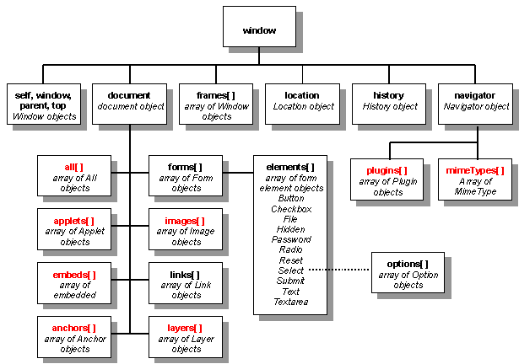

Window.document.div.p like you can access all this using this

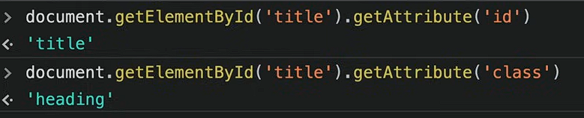

It gets the attribute like id and whats the id it will tell.

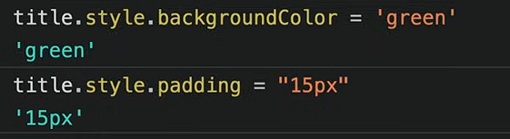

## Difference between innerText vs textContent

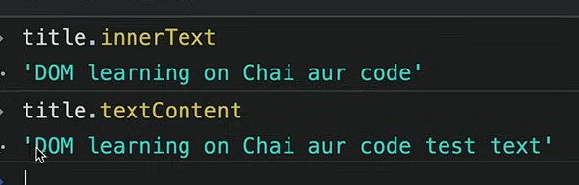

Text content will show that all the hidden element inside the html which is hidden by any css property

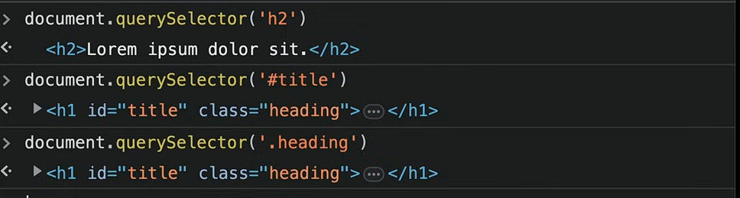

This will only print first one

**Query selector** returns the **nodelist** which looks like array but it is not an array.

We can only use forEach loop in that

**getElementByclassname** returns **HTMLCollection** which we cant use forEach loop and all those

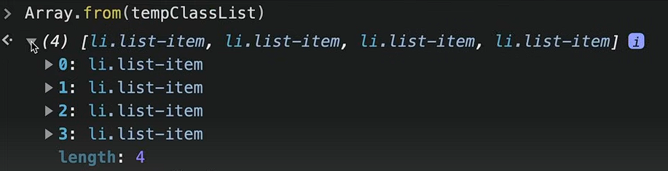

We use Array.from for converting it into a array.

# Children and parents

console.log(parent.children[0])

.children to enter the parents thing

Parent.firstElementChld = gives the first element of the children

.**lastElementChild =** gives the last element of the the children

**.parentElement =**  tells the parent element of the selected

# Creating element using DOM

**document.createElement("div")**

**to add class and id**

div.className = "main"

div.id = Math.round(Math.random()*10+1)

**if you want to add attribute which is not conventional you can add your attribute**

div.setAttribute("set","wet")

## to add element inside that div

first method

 div.innerText = "Sid is supreme"

**second method ( more optimized and more used it saves a one round trip so developers prefer this)**

        const text = document.createTextNode("sid is superb")

        div.appendChild(text)

**New optimized trick for newListOpt**

function newListOpt(langName) {

        const list = document.createElement("li")

        const textnode = document.createTextNode(langName)

        list.appendChild(textnode)

        document.querySelector(".programmingLang").appendChild(list)

    }

    newListOpt("typescript")



**To remove element A**

**||**

# Events in js

Onclick = alert(“heleow”);

We can add this to our html and it will alert but we shouldn’t use this approach. Instead Use event listeners;

const button = document.getElementById("btn")

button.addEventListener("click",function(){}, false)

**addeventlistner** has Three parameters “ click and all submit etc“ , function() {}, false

false is hidden because it is usually false from the get go so you don’t have to write it but in some cases or interview you need to know that false’s true objective.

//attachEvent was first use in times of internet explorer

// jquery –

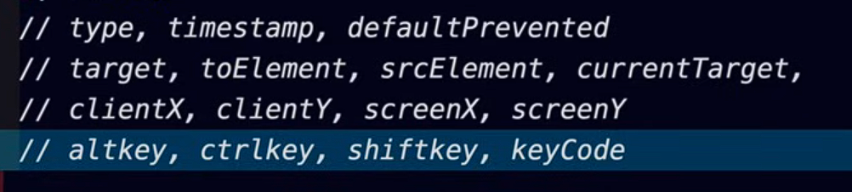

## Event propagation ( true and false is used here )

## For false: ( default yhi rheta h) BUBBLING UP ;

So when you have event listener in two things like in ul and inside the ul

So first thing will print is **BUBBLING UP** means bubble niche se upar jata h likewise inside ul will first be activated then ul .

## For true: Capturing mode

When you capture something in net like fish then the net is form bigger than inwards

Then ul will print first then inside ul

This will stop the bubbling

e.stopPropagation

  const button = document.getElementById("btn")

    button.addEventListener("click",function(e){

        e.preventDefault();

        const remove = e.target.parentNode

        remove.remove();

    }, false)

Remove() ; function

# Asynchronous CODE

Javascript is synchronous

Single threaded

## Execution context

Execute one line of code at a time

Console.log( 1 )

Console.log (2 )

Each operation waits for the first one to complete

## Blocking code and No blocking code

Blocking code = block the flow of program , read file sync

No blocking code = doesn’t block the flow of program, read file async

Biggest blocking code is To read files

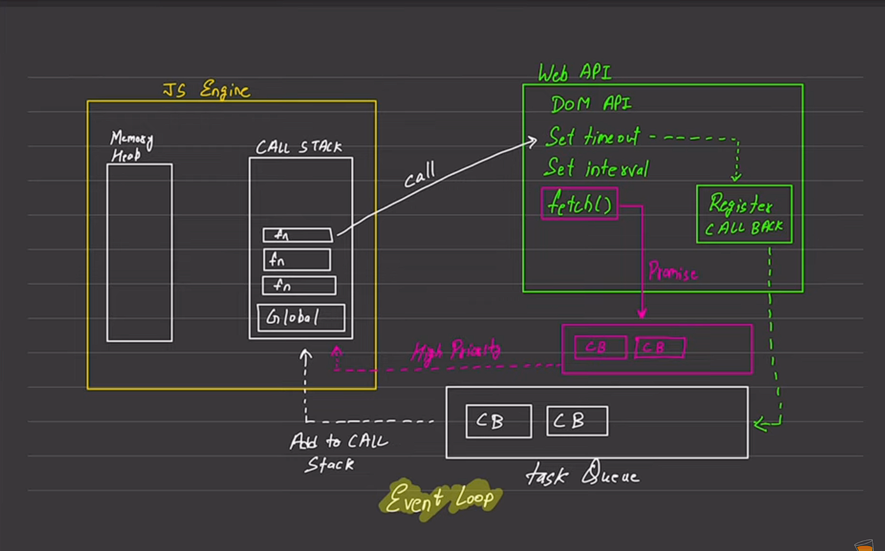

# Async

## Set timeout

It will work after some time.

## setTimeout(function(){

        console.log("working")

    },4000)

One time thing is set timeout it will work one time. Set intervals works more than one time

Can add to function as well

const print = () => {

  console.log("yolo")

}

    setTimeout(print,4000)

we can change text after few seconds too.

const print = () => {

  document.querySelector("h1").innerHTML= "THIS has changed after few seconds"

}

    setTimeout(print,4000)

## Clear Timeout

Clear timeout stops the set timeout from happening. We add it to event listenter to it stopping it we can make a button and all.

## Set interval

setInterval(function(){

    console.log("sid")

},1000,”hey”)

This will keep running after an interval of time.

Whats different from set timout nd set interval is you can pass argument like string at this too

## Clear interval

Used to clear interval

# API

## Json formatter

It is used to format api data in a form we can understand or write that inside the code.

## Randomuser .me

To get random api’

# Promise

The promise object represents the eventual completion (or failure) of an asynchronous operation and its resulting value.

A promise is in one of these states:

* Pending: initial state, neither fulfielled nor rejected.
* Fulfilled: meaning that the operstion was completed successfully
* Rejected: meaning that the operation failed.

**Resolve() => then()**

**Reject() => catch()**

**Finally(function(){“this will run eventually”})**

const newPromise = new Promise(function(resolve,reject){});

## resolve

const newPromise = new Promise(function(resolve,reject){

        setTimeout(function(){

            console.log("database has managed")

            resolve();

        },2000)

    });

    newPromise.then(function(){

        console.log("this has been resolved")

    })

Resolve = then newpromise.then( anfn)

## To do this in one part

new Promise(function(resolve, reject){

        setTimeout(function(){

            console.log("been 10 sec")

            resolve()

        },10000)

    }).then(function(){

        console.log("Its working")

    })

.then only works when you put resolve function in it.

## Value in resolve()

 new Promise(function(resolve, reject){

        setTimeout(function(){

            console.log("been 10 sec")

            resolve({

                userName:"siddharth",

                Email: "siddharthnodiyal323"

            })

        },1000)

    }).then(function(user){

        console.log(user)

    })

We can pass values in resolve mostly it’ll be object.

# Async and Await function

*async* function consumePromiseFive() {

    const promise = await PromiseFive;

    console.log(promise)

}

consumePromiseFive()

async and await works just fine but it doesn’t have the catch functionality which is used for Error throwing.

## For error catching use try and catch

*async* function consumePromiseFive() {

   try {

     const promise = await PromiseFive;

    console.log(promise)

   } catch (error) {

    console.log("error ara bhaijaan")

   }

}

## Data would be In this format for async await

*async* function users() {

    try {

        const response = await fetch("https://jsonplaceholder.typicode.com/users")

        const parsejson = await response.json()

        console.log(parsejson)

    } catch (error) {

        console.log("couldnt parse because",error)

    }

}

users()

through try and catch .

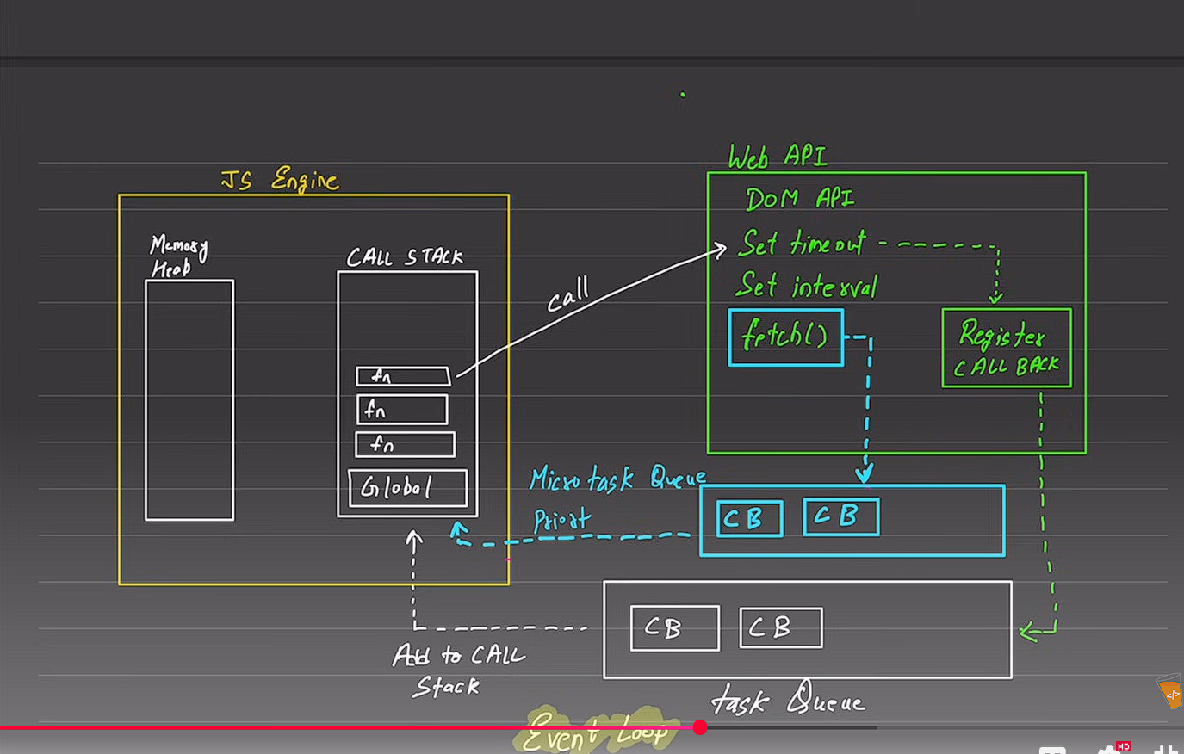

Fetch queue

It is run first that blue line

# 

# OOP in js

Js has prototype

**JavaScript is an object-oriented language**, but it’s **prototype-based**, not class-based like Java or C++.

Objects are created from other objects (prototypes), and **ES6 classes** are just **syntactic sugar** over this system.

**OBJECT –**

Collection of properties and methods

Tolowecase

## Part of oops

1. Object Literals

-constructors

- prototypes

- Classes

- Instances (new, this)

## 4 pillars

**Abstraction**

**Definition:**  
Abstraction means **hiding complex implementation details** and showing only what’s necessary.

**In JavaScript:**  
We achieve abstraction using **classes** and **methods** — we expose only what’s needed for the user and hide the internal working.

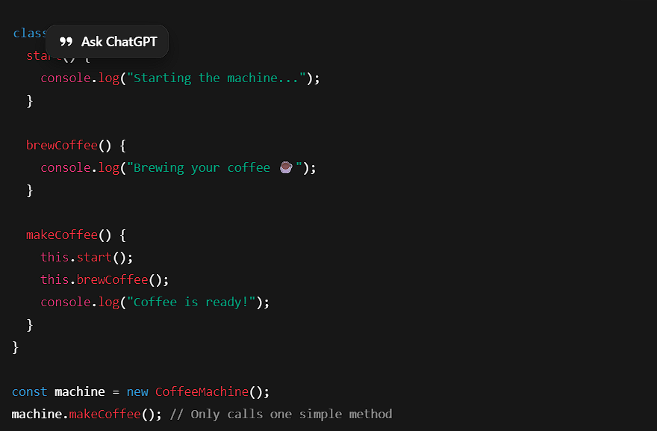

**Encapsulation**

**Definition:**  
Encapsulation means **keeping data (properties)** and **methods (functions)** together inside a class — and **restricting direct access** to some of them.

**In JavaScript (ES2022+):**  
We can use **private fields** using #.

**Inheritance**

**Definition:**  
Inheritance means **one class (child)** can use the properties and methods of **another class (parent)**.

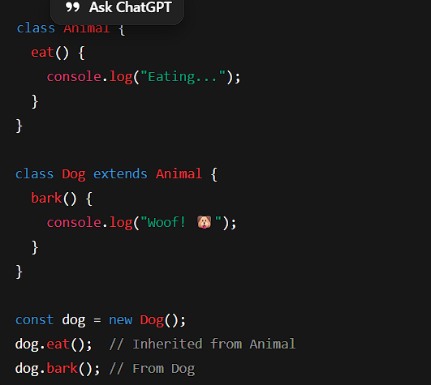

The Dog class inherits from Animal.  
It **reuses** code and can **add its own behavior**.

**Polymorphism**

**Definition:**  
Polymorphism means **one method behaves differently** depending on which object is using it.  
(“Poly” = many, “Morph” = forms)

Bark! 🐕

Meow! 🐱

Some generic sound

The **same method name (makeSound)** behaves **differently** for each class.  
That’s **polymorphism**.

## Literal object and this keyword

const user = {

    username: "Siddharth",

    age: 20,

    details: function(){

       console.log( `Hey ${this.username} you turned ${this.age} Years Old isnt it amazing`)

       return;

    }

}

console.log(user.details())

this is used to state that we are talking about this scope other wise it will say username and age is undefined. ( current context) means the whole object

## Constructor Function

Write new before calling any function will make it not change the previous function

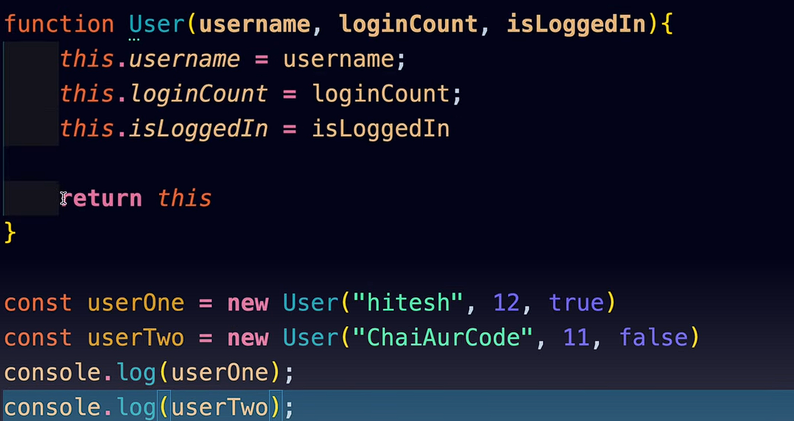

## Create Prototype

function createUser(username,score){

 this.username = username

 this.score = score;

}

createUser.prototype.incriment = function(){

    this.score++;

}

const chai = new createUser("CHai",55)

const tea = new createUser("Tea",10)

createuser.Prototype.incriment uske andar apna function.

## Inheritance

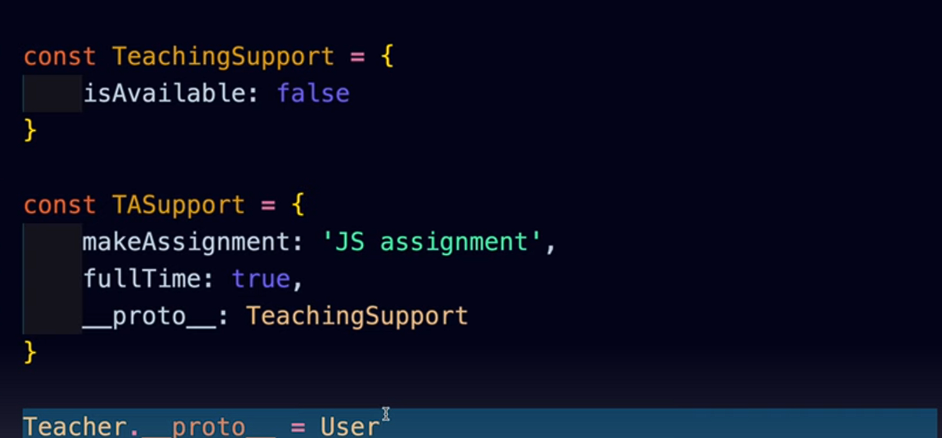

Modern syntax



This means the teachingsupport inherits it property to the teacher.

# Call

function setUsername(username){

    this.username= username;

    console.log("called")

}

function users(username,email,password){

    setUsername.call(this,username)

    this.email = email;

    this.password = password;

}

console.log(new users("Sid","sidd#gagagd","hasshass"))

this calls from different function add value to it, its like a connection between them.

# Classes in js

As such classes don’t exist in js its just way of writing in syntax of class unlike other programming languages like java c++.

After Es6

Constructor is called as soon as New keyword is called.

class user {

    constructor(name, email, password){

        this.name = name

        this.email = email

        this.password = password

    }

    encryptPass(){

        return `${this.password} is you password `

    }

}

const sid = new user("sid","siddharthnaudiyal144","hahahah")

console.log(sid.encryptPass())

## inheritance

super keyword is used to get the value from the parent

class user{

    constructor(username){

        this.username = username

    }

    logme(){

        console.log(`Username is ${this.username}`)

    }

}

class teacher *extends* user{

    log2(){

        console.log(super(username))

    }

}

Extend and super